SCHOOL OF COMPUTER SCIENCE AND ARTIFICIAL INTELLIGENCE |  |  |  |  | DEPARTMENT OF COMPUTER SCIENCE ENGINEERING
Program Name: M. Tech/MCA/MSC |  |  |  | Assignment Type: Lab |  |  | AcademicYear:2025-2026
Course Coordinator Name |  |  |  | Venkataramana Veeramsetty
Course Code |  |  |  | Course Title |  | AI Assisted Problem Solving Using Python
Year/Sem |  |  | II/I | Regulation |  | R25
Date and Day  of Assignment |  |  | Week5 - Tuesday | Time(s)
Duration |  |  | 2 Hours | Applicable to  Batches |  | M. Tech/MCA/MSC
AssignmentNumber:14.3(Presentassignmentnumber)/24(Totalnumberofassignments)
 | Q.No. | Question |  |  |  |  |  | ExpectedTime  to complete
 | 1 | Lab 14 – Web Frontend Development: AI-assisted HTML/CSS/JS with Python  Lab Objectives  - To understand how AI can generate HTML/CSS/JS templates.  - To practice integrating frontend and backend (Python) for small apps.  - To evaluate AI-generated code for readability, reusability, and responsiveness.  Learning Outcomes  After completing this lab, students will be able to:  - Generate HTML/CSS layouts using AI tools.  - Add JavaScript interactivity with AI suggestions.  - Integrate basic Python (Flask/Streamlit) backend to serve frontend.  - Evaluate AI-generated web code for responsiveness and usability.  - Debug and refine AI-generated frontend code.  Task Description #1 – AI-generated HTML Page  Task: Ask AI to generate a simple HTML homepage for a "Student Info Portal" with a header, navigation menu, and footer.  Prompt:  generate a simple HTML homepage for a "Student Info Portal" with a header, navigation menu, and footer.  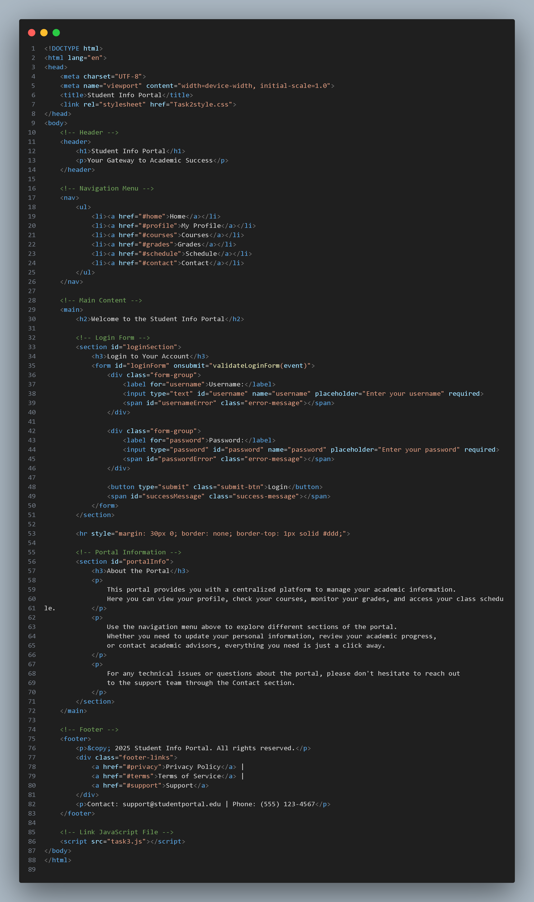  Expected Output:  - HTML code with <header>, <nav>, <footer>.  - Clean indentation, proper tags, and comments.  Task Description #2 – CSS Styling  Task:  Use AI to add CSS styling to Task #1 homepage for:  - Responsive navigation bar.  - Centered content section.  - Footer with light gray background.  Prompt: Generate the CSS styling to Task #1 homepage for:  - Responsive navigation bar.  - Centered content section.  - Footer with light gray background.  /* Global Styles */  * {  margin: 0;  padding: 0;  box-sizing: border-box;  }  body {  font-family: 'Arial', sans-serif;  line-height: 1.6;  color: #333;  background-color: #f4f4f4;  }  /* Header Styles */  header {  background-color: #2c3e50;  color: white;  padding: 20px 0;  box-shadow: 0 2px 5px rgba(0, 0, 0, 0.1);  }  header h1 {  text-align: center;  font-size: 2.5em;  margin-bottom: 10px;  }  header p {  text-align: center;  font-size: 0.95em;  color: #ecf0f1;  }  /* Responsive Navigation Bar */  nav {  background-color: #34495e;  padding: 0;  margin: 0;  box-shadow: 0 2px 5px rgba(0, 0, 0, 0.1);  }  nav ul {  list-style: none;  display: flex;  justify-content: center;  flex-wrap: wrap;  padding: 0;  margin: 0;  }  nav li {  margin: 0;  }  nav a {  display: block;  color: white;  text-decoration: none;  padding: 15px 20px;  transition: background-color 0.3s ease;  }  nav a:hover {  background-color: #2c3e50;  }  /* Responsive Design for Navigation */  @media (max-width: 768px) {  nav ul {  flex-direction: column;  }  nav li {  width: 100%;  }  nav a {  text-align: center;  border-bottom: 1px solid #2c3e50;  }  header h1 {  font-size: 2em;  }  }  @media (max-width: 480px) {  nav a {  padding: 12px 15px;  font-size: 0.9em;  }  header h1 {  font-size: 1.5em;  }  }  /* Centered Content Section */  main {  max-width: 1200px;  margin: 30px auto;  padding: 20px;  background-color: white;  border-radius: 5px;  box-shadow: 0 2px 10px rgba(0, 0, 0, 0.1);  min-height: 400px;  }  main h2 {  color: #2c3e50;  margin-bottom: 20px;  border-bottom: 3px solid #3498db;  padding-bottom: 10px;  }  main p {  margin-bottom: 15px;  color: #555;  text-align: justify;  }  /* Login Form Styles */  #loginSection {  background-color: #f9f9f9;  padding: 20px;  border-radius: 5px;  margin-bottom: 20px;  border-left: 4px solid #3498db;  }  #loginSection h3 {  color: #2c3e50;  margin-bottom: 15px;  }  .form-group {  margin-bottom: 15px;  }  .form-group label {  display: block;  margin-bottom: 5px;  color: #2c3e50;  font-weight: bold;  }  .form-group input {  width: 100%;  padding: 10px;  border: 1px solid #bdc3c7;  border-radius: 4px;  font-size: 1em;  transition: border-color 0.3s ease;  }  .form-group input:focus {  outline: none;  border-color: #3498db;  box-shadow: 0 0 5px rgba(52, 152, 219, 0.3);  }  .submit-btn {  background-color: #3498db;  color: white;  padding: 10px 20px;  border: none;  border-radius: 4px;  font-size: 1em;  cursor: pointer;  transition: background-color 0.3s ease;  margin-top: 10px;  }  .submit-btn:hover {  background-color: #2980b9;  }  .submit-btn:active {  transform: scale(0.98);  }  .error-message {  display: none;  color: #e74c3c;  font-size: 0.9em;  margin-top: 5px;  }  .success-message {  display: none;  color: #27ae60;  font-size: 0.95em;  margin-top: 10px;  font-weight: bold;  }  #portalInfo h3 {  color: #2c3e50;  margin-top: 20px;  margin-bottom: 15px;  }  /* Responsive Form Styles */  @media (max-width: 768px) {  #loginSection {  padding: 15px;  }  .form-group input {  padding: 8px;  font-size: 0.95em;  }  .submit-btn {  padding: 8px 15px;  font-size: 0.95em;  }  }  /* Responsive Content Section */  @media (max-width: 768px) {  main {  margin: 20px 10px;  padding: 15px;  }  main h2 {  font-size: 1.5em;  }  }  /* Footer with Light Gray Background */  footer {  background-color: #d3d3d3;  color: #333;  text-align: center;  padding: 20px;  margin-top: 30px;  font-size: 0.9em;  border-top: 2px solid #999;  }  footer p {  margin: 5px 0;  }  .footer-links {  margin: 10px 0;  }  .footer-links a {  color: #2c3e50;  text-decoration: none;  margin: 0 10px;  font-weight: bold;  }  .footer-links a:hover {  text-decoration: underline;  color: #3498db;  }  /* Responsive Footer */  @media (max-width: 768px) {  footer {  padding: 15px;  font-size: 0.85em;  }  .footer-links a {  margin: 0 5px;  display: inline-block;  }  }  @media (max-width: 480px) {  .footer-links {  display: flex;  flex-wrap: wrap;  justify-content: center;  gap: 5px;  }  .footer-links a {  margin: 0;  }  }  Expected Output:  - HTML + CSS combined.  - AI explains how CSS classes apply.  Expected Output: AI refactors with with open() and try-except:  Task Description #3 – JavaScript Interactivity  Task: Prompt AI to generate a JS script that validates a simple login form (non-empty username/password).  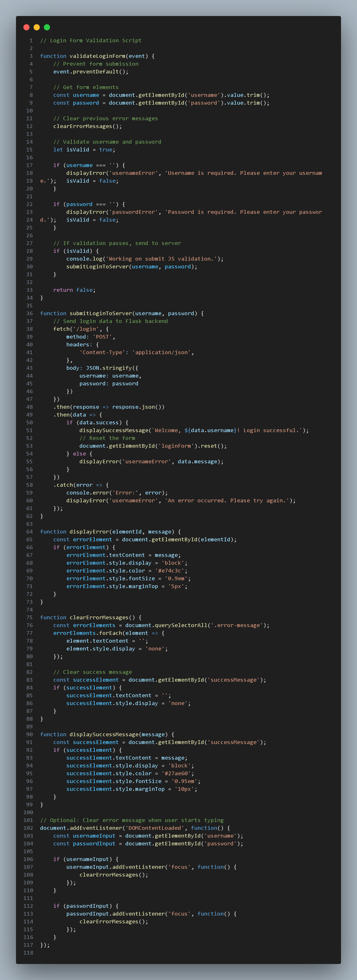  Expected Output:  Working on submit JS validation.  Clear error messages if inputs are empty.  Task Description #4 – Python Backend Integration  Task: Ask AI to generate a Flask app that serves the HTML form (Task #3) and prints the username on successful login.  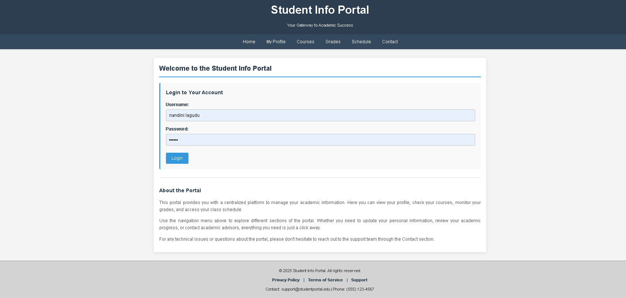 |  |  |  |  |  | Week5 - Tuesday

